Instructions for downloading the new version of Signal Scout

- Go to www.semaphoresoftware.co/download and scroll down to the Green Bar labeled Download Signal Scout. This will open a new window.
- In the new window, click on the download arrow in the top right corner.

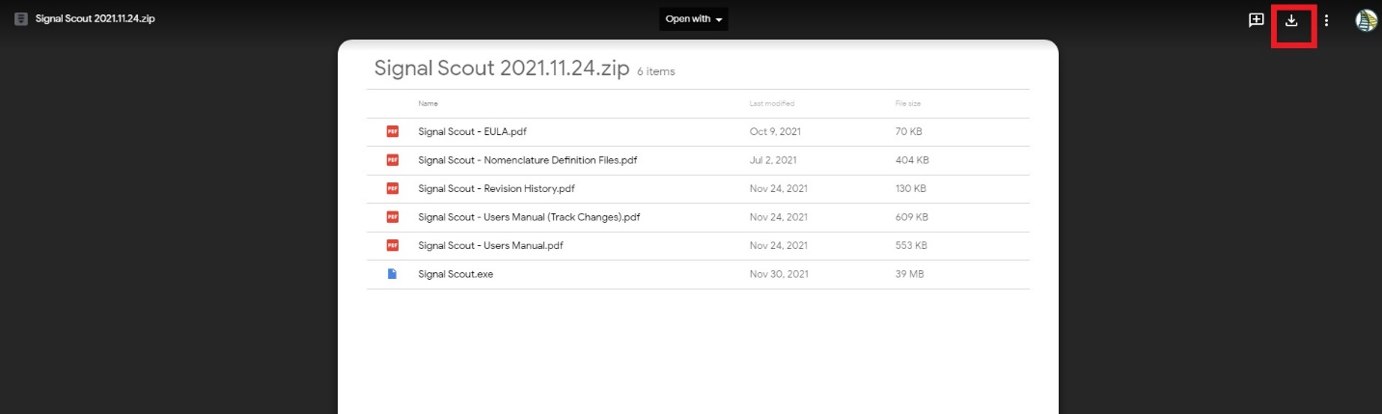

- The following message might pop up, click on Download anyway.

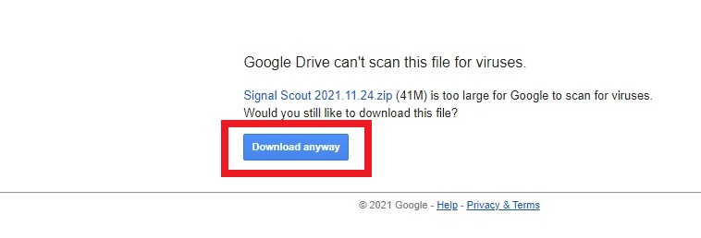

- A window will pop up to select where to save the new Signal Scout Zip File. Make sure to find the destination folder where your old version of Signal Scout is located, and save it there, so it will replace that version in step 6.

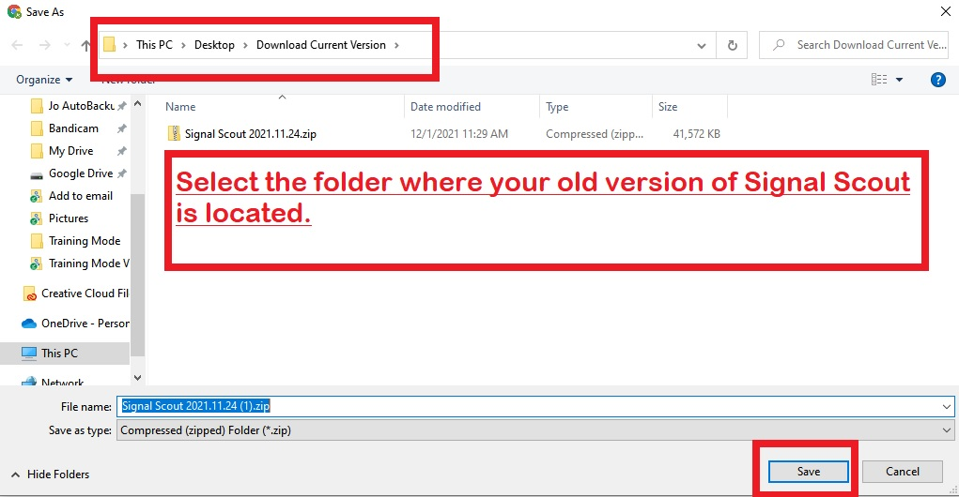

- Once downloading is complete, open the zip file at the bottom of the screen by clicking on it.

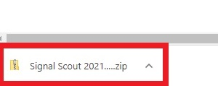

- A new window will pop up. Click on Extract All at the top.

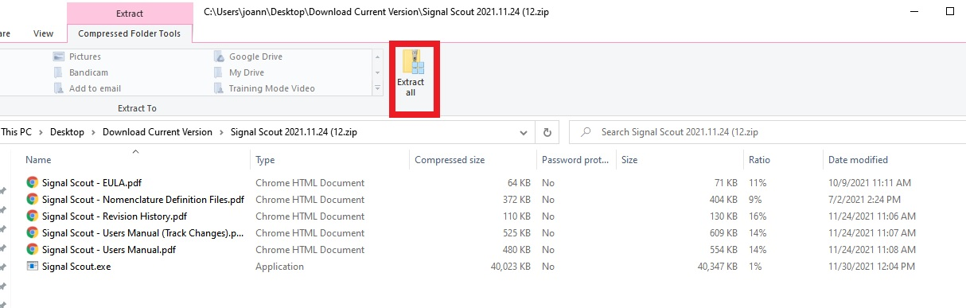
- In the new window, select where you want the new version of Signal Scout to be located by clicking on Browse. Selected the destination folder where your old version is located (you want to overwrite the existing files with the new ones). Click on Extract at the bottom.

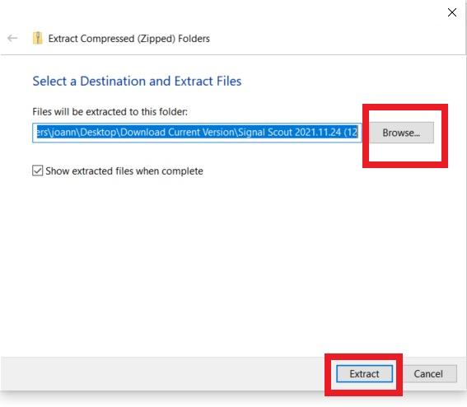

- Make sure that the new version replaces the old version by making sure they are in the same destination folder or by manually adding the new version to the same destination folder of the old version.

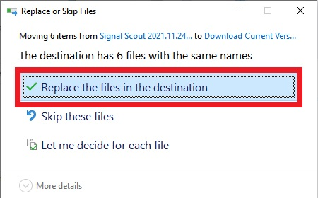

- When using the new version of Signal Scout for the first time, the following message might pop up. If it does, click on More Info.

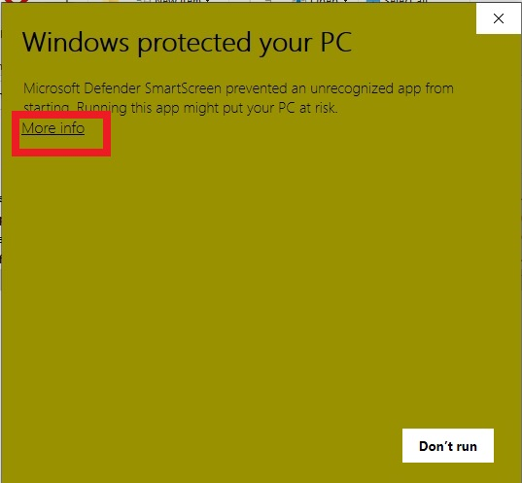

- Now click on Run anyway at the bottom.

- Signal Scout will now open on your screen, and you have successfully installed the new version!

